**Part 16 – Midpoint Formula**

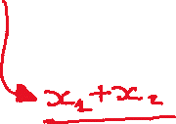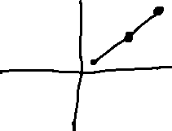

**Coordinates of the midpoint:**

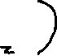

**Example.** Find the midpoint of the segment between the points

